PAETEC
Product Catalog Editor
System Design Document
SystemDesignDocument0000.doc
Draft 1.15
April 1, 2009
Team Spy Penguins

Revisions
Version | Primary Author(s) | Description of Version | Date Completed
1.0 | Tom Sheppard  Phil Schmitte  Joe Plourde  Rob Marinaro  Mark Chadbourne | Initial Revision | 2/5/09
1.1 | Joseph Plourde | Added diagrams and descriptions | 3/2/09
1.2 | Phillip Schmitte | Revised definition design section | 3/5/09
1.3 | Joseph Plourde | Added Outline and Descriptions of Diagrams | 3/5/09
1.4 | Mark Chadbourne | Grammatical corrections, removed export info | 3/9/09
1.5 | Phillip Schmitte | Updating master definition section | 3/12/09
1.6 | Joe Plourde | Added IO Diagram | 3/12/09
1.7 | Spy Penguins | Updated IO Diagram | 3/12/09
1.8 | Mark Chadbourne | Revised Entity Diagram | 3/13/09
1.9 | Joe Plourde | Added XML Parsing | 3/16/09
1.10 | Tom Sheppard | Added SVN library section | 3/16/09
1.11 | Tom Sheppard  Mark Chadbourne | Revised for readability, updated Entity diagram | 3/18/09
1.12 | Tom Sheppard | Updated design diagrams | 3/19/09
1.13 | Mark Chadbourne | Added sequence diagram from external document, revised XML/Persistence diagram and descriptions | 3/20/09
1.14 | Mark Chadbourne  Tom Sheppard  Joe Plourde | Added second sequence diagram and description. Modified Entity Management Subsystem diagram. | 3/26/09
1.15 | Tom Sheppard | Added Enums for feature/attribute specific parameters. Also listed these parameters in section 2 | 4/1/09

Contents
1 Introduction 1
1.1 Overview 1
2 Master Definition 2
2.1 Description 2
2.1.1 Entities 2
2.1.2 Entity Specific Parameters 2
2.1.3 Other Definition Elements 2
2.1.4 File Structure 3
2.2 Visual Representation 4
3 Class Structure Diagrams 5
3.1 Subsystem Level 5
3.1.1 Description 5
3.1.2 Diagram 6
3.1.3 UI View Subsystem 7
3.1.3.1 Description 7
3.1.3.2 Diagram 8
3.1.4 UI/System Manager 9
3.1.4.1 Description 9
3.1.4.2 Diagram 10
3.1.5 Entity Subsystem 11
3.1.5.1 Description 11
3.1.5.2 Diagram 12
3.1.6 XML/Persistence 14
3.1.6.1 Description 14
3.1.6.2 XML Parsing 14
3.1.6.2.1 Selected Library 14
3.1.6.2.2 Rejected Libraries 14
3.1.6.2 SVN Interaction 14
3.1.6.2.1 Selected Library 14
3.1.6.2.2 Rejected Libraries 14
3.1.6.3 Diagram 15
4 Sequence Diagrams 16
4.1 Create Product 16
4.1.1 Description 16
4.1.2 Diagram 17
4.2 View Product Catalog 18
4.2.1 Description 18
4.2.2 Diagram 19

Introduction

Overview

This document provides a more detailed view of the Product Catalog System through a breakdown of each subsystem into classes and how the classes interact with each other. This document is setup to provide details about the Master Data Definition that will be used for the system and then follows with a description about the subsystems and how they interact with each other. The subsystems UI View, UI/System Management, Entity Management, XML/Persistence and Export are all discussed in the later sections after the overall system design and are depicted using UML class diagrams to convey their details and structure.
The overall purpose of this document is to provide the stakeholders with a more fine-grained visualization of what the system will look like when it is implemented. Within the design of the system several Gang of Four design patterns such as the strategy pattern, decorator pattern, builder pattern and singleton patterns are used to help provide some basis and core stabilization to the system design. The use of these patterns helped provide a system that contains low-coupling and flexible to allow for future modification without much trouble.

Master Definition

Description

Entities
Product catalogs are defined as a hierarchical structure of entities. The following is a breakdown of each of the entities and what can be contained within them.
Product Catalog: Contains products, attributes, and business rules.
Product: Contains features, attributes, connection numbers, and products.
Feature: Contains attributes and features.
Attribute: Contains no other entities. An attribute does contain any number of conditions and a default result.
These two definition elements are described below.
Connection Number: Contains no other entities.
Business Rules: Contains references to products, features, attributes, and/or connection numbers.

Entity Specific Parameters
These are parameters that are not common to all entities. All parameters are listed with their possible values
Feature:
- Pricing: {Optional, Required, Recommended}
Attribute:
- Profitability: {N/A, Yes, No}
- Commissions: {N/A, Yes, No}
- Waivability: {N/A, Yes, No}
- EMR: {N/A, Yes, No}
- Pricing: {N/A, MRC, NRC, Usage}
- MMF: {N/A, 0-100%}

Other Definition Elements
These elements are not entities in the definition. Their purpose is to help describe the hierarchy or assist in the description of an existing entity.
Root: This is the parent element in our hierarchy. It contains a reference to every product catalog in the system.
Condition: This element describes one condition that may be applied to an attribute. It contains any number of expressions and one result. If all the expressions pass the values described in the result should be used.
Expression: This element describes a Boolean expression. The expression contains a reference to any attribute in the product catalog, an equivalency operator, and a value.
Result: This describes what values the attribute should use if the condition is met.

File Structure
Products and product catalogs will be defined and stored in SVN as three different XML file types:

Product File: Contains all product related information such as description and name. It will also contain every attribute, feature, connection numbers, and references to other products.
Product Catalog File: Contains what version the product catalog is, contains attributes and business rules and references to the products within it. This also contains product catalog specific information such as a name and description. The business rules that are contained within this file will reference multiple products or entities contained within multiple products.
Root File: There will be one root file that contains a reference ID to every product catalog in the system.

Visual Representation
This Entity Relationship Diagram shows which entities can be contained by other entities, and how entities are related. Multiplicities are shown for each compositional relationship. This is not a class diagram, which would show member data and functions.

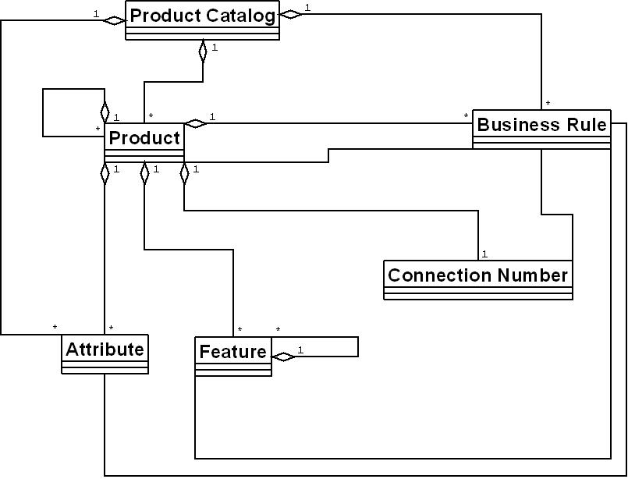

Class Structure Diagrams

Subsystem Level

Description
From a subsystem standpoint, this diagram shows a high level view of the system.
The UI View subsystem will be responsible for providing and handling user input and then sending them to the UI/System Manager subsystem. This interaction between the UI View and UI/System Manager will be implemented using Google Web Toolkit (GWT), which provides the system with a GUI that can be easily removed, while at the same time also providing a means for communication between the client and the server using GWT Remote Procedural Calls (GWT RPC).
The UI/System Manager, once it is provided with a request from the UI View, will determine how to handle the request and which other subsystems it will be needed to complete the transaction with the client.
The Entity Management subsystem will be responsible for maintaining a collection of the entities i.e. Products, Features and etc. It will also provide the interaction with the XML/Persistence Subsystem that handles all transactions with the Subversion (SVN) repository.
Finally the Export subsystem will be responsible for allowing the user to export to a format that is foreign to the Product Catalog System and will provide the user with ways to define the format that they wish to export to.

Diagram
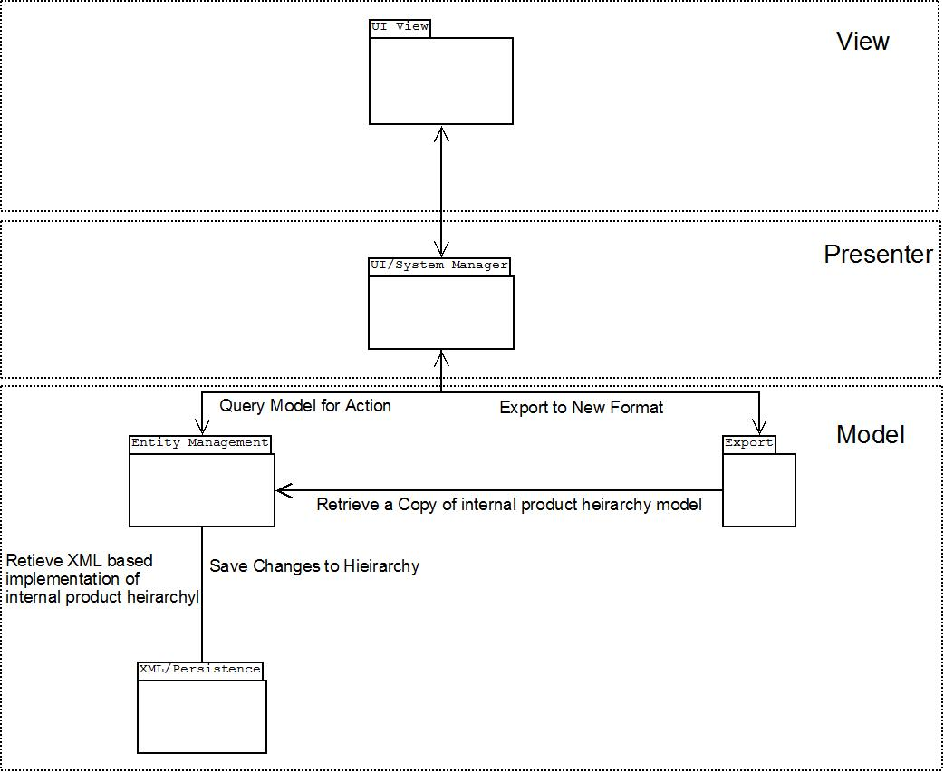

UI View Subsystem

3.1.3.1 Description
The UI View as mentioned previously will handle all user interaction and will maintain the connection to the server using GWT RPC. In this subsystem there are a few key classes and patterns at work.
The first is the idea of a ClientView, which is a digital representation to the system of what the user will be seeing and interacting with. The ClientView will contain a ViewSocket that is able to have different views plugged into it based upon user interaction. ViewSocket is used to contain the actual screen that the user will see and will draw it to the screen upon being prompted by the ClientView. The ScreenManager manages the ClientView and all the entities that exist on the client side, as it will send the RPC request to the server and then will format the output it receives into what is called a ViewPlug.
The ViewPlug is the type of screen that the user will see, by utilizing a decorator pattern. Each plug will fit into the ViewSocket and can be changed as mandated by the ScreenManager, when the next view is to be shown to the user. The actual plugs themselves will be created on the server side and then passed back through the RPC callback value and then un-marshaled into the view.
Finally the ClientCatViewAsync and ClientCatView are the GWT RPC interfaces that will be created in order for the client to actually communicate with the server.

3.1.3.2 Diagram
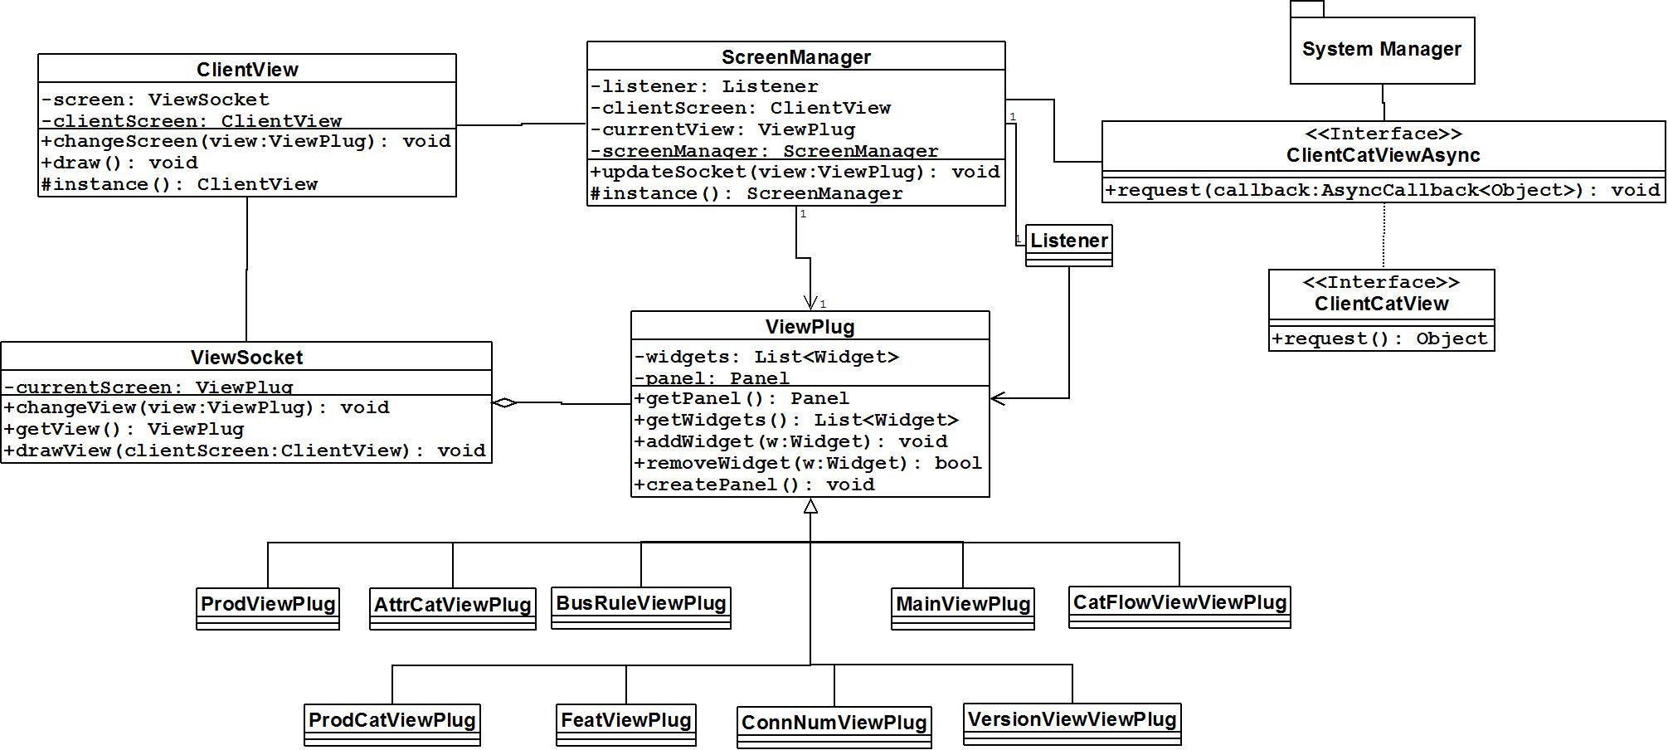

UI/System Manager

3.1.4.1 Description
This subsystem will be responsible for handling all client side requests and getting the appropriate response sent back. There are two major players in this portion of the system, the ServerManager and the ViewCreator.
The ServerManager will be used to determine where to get the information needed to respond to the client. ServerManager is a singleton because there should be only one ServerManager receiving requests and then talking to the rest of the system. It could possibly create a state issue within the system; therefore the singleton pattern is used to prevent this from occurring. The ServerManager will determine if it needs to contact the Entity Management Subsystem or the Export Subsystem for outside contact, however it can also talk with the ViewCreator.
The ViewCreator will be responsible for managing the building of the view plugs. This is done through a builder pattern, where a view is created when the ViewCreator determines which view will need to be created for the next user screen based upon what it is given for information from the ServerManager.

3.1.4.2 Diagram
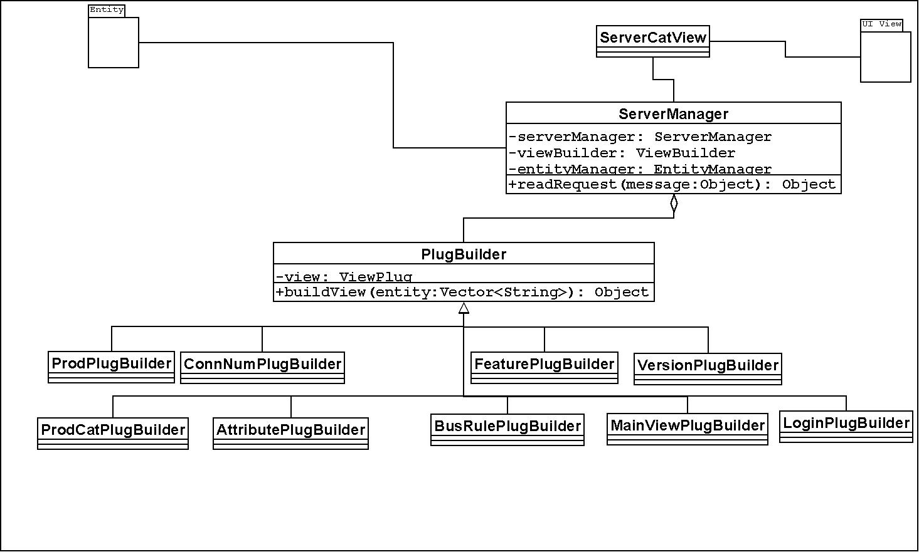

Entity Subsystem

3.1.5.1 Description
This subsystem will maintain the system model of the product catalog hierarchy and will provide the UI/System Manager with the ability to manipulate the system model and the underlying file system that is setup in SVN. This is set up using a composite type entity that can be many different types of entities such as a Product or Feature. The parent class, Entity, is abstract, and cannot itself be instantiated as a type, however, its children, which share all the elements found within Entity, are concrete.
The relations between different entity objects, illustrated earlier in the visual representation will be enforced via the implementation of the validTypes element of each entity, which will consist of a list of other entity types that are able to be attached to each class as a child. The addEntity method in EntityManager and the addChild method in Entity will facilitate the creation of a Product Catalog’s structural hierarchy, and re-build said hierarchy each time it is re-read from XML.
Through polymorphism each entity will be able to have access to a list of entities that it contains and that will be shown when a view for this entity is created. The EntityManager is responsible for maintaining a consistent and correct representation of the product hierarchy and for communicating with the ServerManager and the XML/Persistence subsystem.
The Condition, Expression, and Result classes exist to capture a conditional restraint on an Attribute object. Each Attribute can contain multiple Condition objects, which each be made up of one or more Expression and a single Result. The Expression will contain a reference to the outside attribute whose value is being used as a constraint, along with an operator (<, >, =, etc…) and a value for comparison, to determine if the condition is met. Each Result will contain a list of valid values given the condition is satisfied. The Attribute itself will also contain a single Result, which will be used to represent its default set of valid values.

3.1.5.2 Diagram
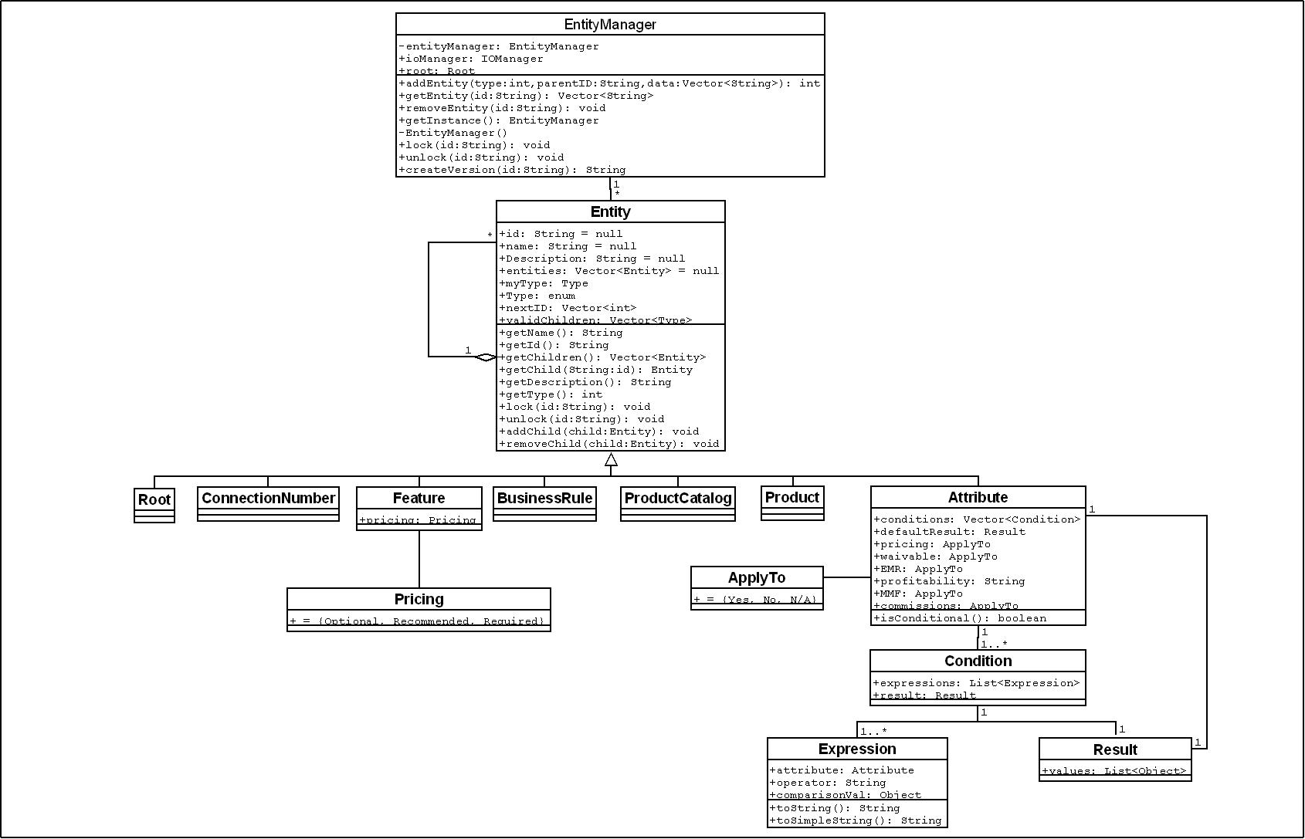

XML/Persistence

3.1.6.1 Description
This subsystem will have full responsibility for communicating with the SVN repository, by updating and committing changes that were done in the system model. The IOManager will be responsible for communicating with the EntityManager, by providing access to the IOCommunicator. IOCommunicator is a class that is extended by FileCommunicator to communicate with the file system, and can be further extended by SVNCommunicator to communicate with the SVN server, should this feature be implemented (diagram retains this class to illustrate its intended location should the extension be made). The Communicator objects will utilize a corresponding ParsingHandler object that will be used to convert to and from entity objects. Currently the concrete parser available will be the XMLParser. This subsystem follows an abstract factory pattern that provides the system with the ability to be adapted to a different form of persistence, such as an Oracle Database at a later time. To change the form of persistence a Communicator class and a Handler class will have to be created to provide specifics as to how an entity should be represented in the persistence. (It should be noted that a new handler class is not needed if the format in which the files are saved is unaltered. For example, to support SVN, only a new Communicator class need be implemented, since both the current file system implementation and the SVN server would store files formatted to satisfy our XML schema.)

3.1.6.2 XML Parsing

3.1.6.2.1 Selected Library
XML parsing will be done by the native Java XML parser JAXP. The reason for this is that JAXP contains both DOM and SAX implementations that can be utilized as needed. This will provide flexibility from the standpoint that if one particular solution does not fit during development, the other method can be used instead. Secondly, there would be no need for a reliance on an external library, thus providing no licensing issues and compatibility issues with Java, as it has been supported since Java 1.4 and this system shall be implemented using Java 1.5.

3.1.6.2.2 Rejected Libraries
Some of the rejected libraries were dom4j, XMLPULL, and JDOM. They were rejected due to the fact that JAXP seemed to be a better alternative by providing a couple different approaches to XML Parsing. These libraries would also be external to Java and could pose reliance and licensing issues.

3.1.6.2 SVN Interaction

3.1.6.2.1 Selected Library
For Java interactions with SVN, we have chosen the SVNKit libraries. SVNKit was chosen because it has an easy to use interface, where every function is mirrored by an SVN command-line command. It was also chosen because SVNKit is currently in use at PAETEC, which means there are no licensing issues.

3.1.6.2.2 Rejected Libraries
A rejected alternative was the JavaHL library. This library was considered in case there had been licensing issues with SVNKit, and rejected when SVNKit was cleared for use. JavaHL is an underlying component in SVNKit, and the interface is not as intuitive and easy to link to SVN command-line commands.

3.1.6.3 Diagram
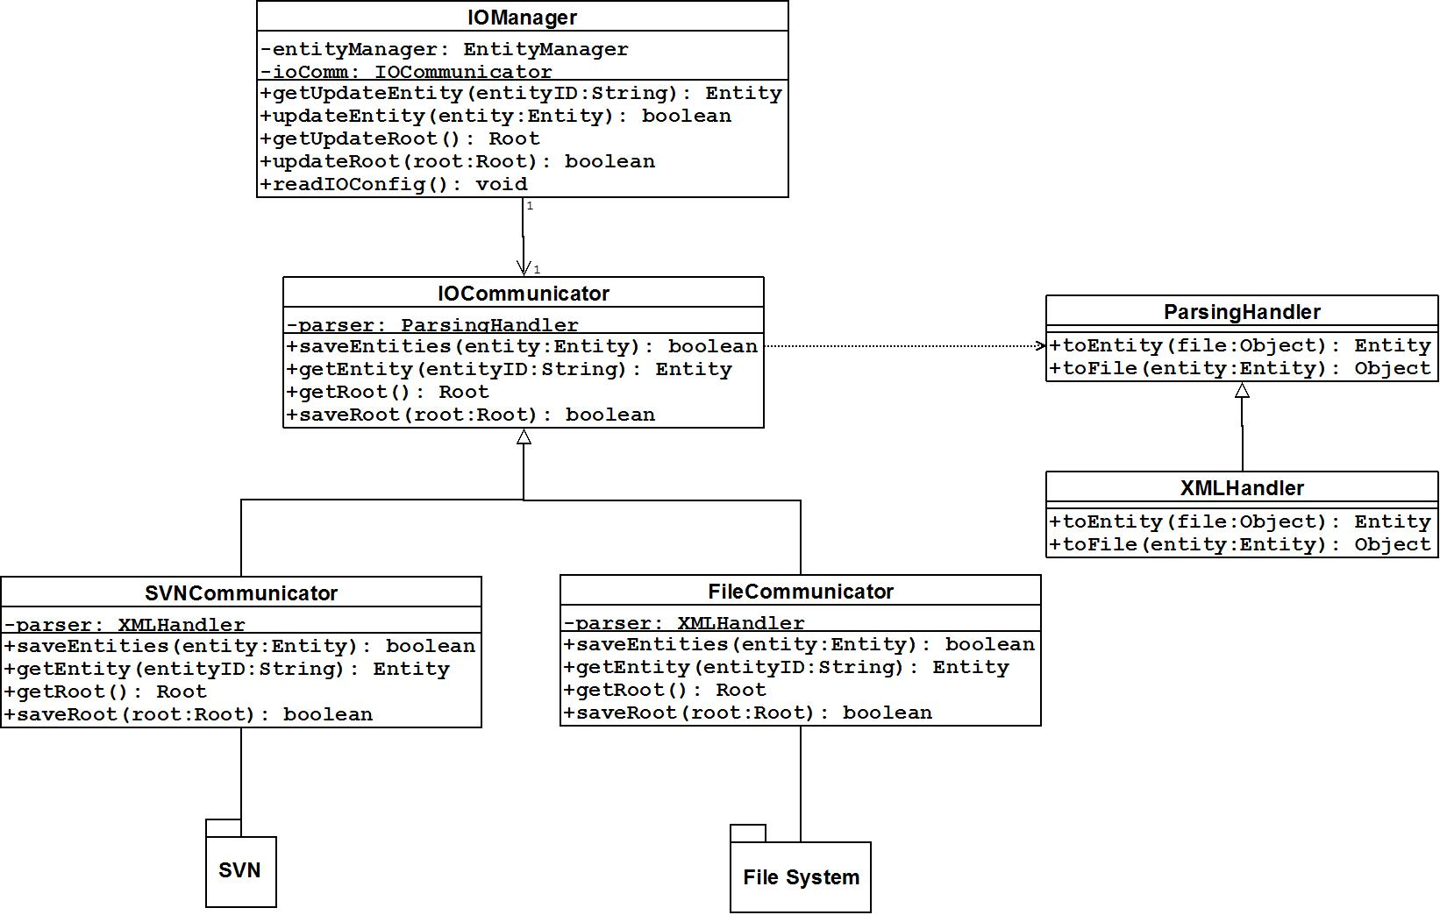

Sequence Diagrams

Create Product

Description
This diagram illustrates the creation of a completely new product from start to finish. It goes through the creation of a new Product object within the Entity Management subsystem based on the incoming user request. Following this is the creation of a new file to persist the gathered data, its translation from an object representation to XML (via the XMLParser), and finally the saving of the file in the file system. Finally, the diagram shows the path travelled to display the newly-created Product to the user, which illustrates communication back from the server to the client side, initiating a view change to display the input information as a new Product object to the user.

Diagram
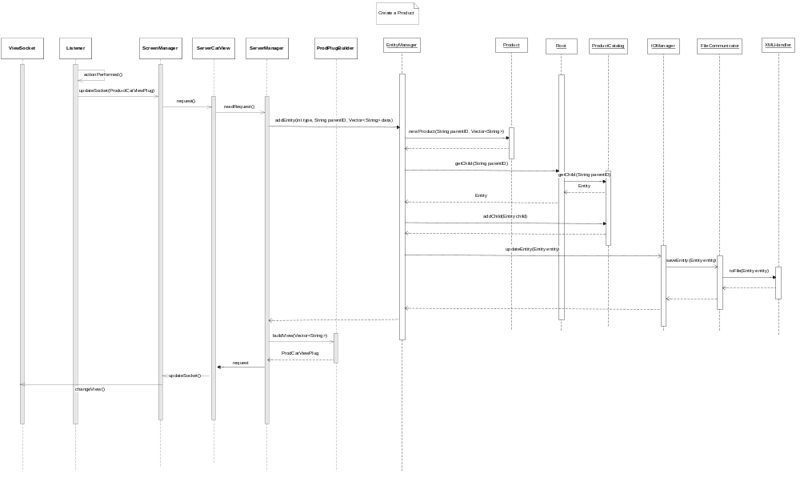

View Product Catalog

Description
This diagram demonstrates what occurs when a user views all the catalogs that exist within the system. The client upon loading this view sends a request to the server for all the catalog names and IDs that exist within the model. The server then structures the request into a format that the EntityManager will understand and passes control to the Entity Management subsystem. Upon being told to get the product catalog names and IDs, the EntityManager queries the root entity to give it this information, so that it can be packaged and returned to the UI. After the information is retrieved, the EntityManager formats it in such a way that the ServerManager can understand. At this point, the information is then given to the appropriate view builder to format the information in a way that the corresponding UI Plug will be able to understand. The information is then returned to the UI by way of a callback from the request sent earlier. Once on the UI side, the data is placed in the correct view and then that view is drawn to the screen.

Diagram


